# Assessment Portfolio

# Assignment 1: Learner Outcomes

**Learning Outcomes**

|  |  |  |
| --- | --- | --- |
| **Learning Outcomes** | **Blooms Taxonomy** | **Level / Difficulty** |
| **Q1**: Analyze the beneficial impact of microbes to at least two different environments. | Analyze | Level: Analysis |
| **Q2**: Predict and conclude how the removal of microbes can negatively affect a given system. | Predict  Conclude | Level: Comprehension and Evaluation  Higher order thinking |
| **Q3**: Assess the importance of microbial fermentation on food and beverage production (e.g., bread, cheese, yogurt, wine, beer, etc.). | Assess | Level: Evaluation  Higher Order thinking |
| **Q4**: Explain how the presence of a microorganism elicits a cellular or humoral specific immune response. | Explain | Level: Comprehension |
| **Q5**: Discuss an example of host-parasite (e.g., human and microbes, bacteria and phage, etc.) coevolution. | Discuss | Level: Comprehension |
| **Q6:** Describe and assess how the human microbiome influences the host human organism. | Describe  Assess | Level: Comprehension and Evaluation  Higher order thinking |
| **Q7**: Describe and assess a situation that could lead to the normal microbiota causing disease in an individual. | Describe  Assess | Level: Comprehension and Evaluation  Higher order thinking |

**Essential Questions**

|  |
| --- |
| **EQ 1**: What are the physical and functional characteristics of bacteria? |
| **EQ 2**: What roles (both positive and negative) do bacteria play in our everyday lives? |

# Assessment Portfolio

# Assignment 2: Formative Assessment Examples for an Online Microbiology Course

|  |  |  |
| --- | --- | --- |
| **Assessment Activity** | **Technology** | **Alignment with Learning Outcome # from AP #1** |
| Student-Led Voice Thread Posts with Direct Responses | Voice Thread integrated into Blackboard Classroom | LO #1  LO #3 |
| “Two Roses and a Thorn”  Describe 2 Things you learned / liked about the module and 1 thing you need to learn more about / don’t understand | Google Forms embedded into Blackboard classroom | LO #2  LO #5 |
| Blackboard Wiki Page Development w/ Peer and Instructor Feedback | Wiki Development in Blackboard | LO #4  LO #6  LO #7 |

# Formative Assessment #1: Student-Led Voice Thread Posts with Direct Responses

Throughout the course, students will respond to various voice thread posts related to topics covered within the modules during the Microbiology course.

Students will respond on a voice thread post created by the instructor. Students will have the option of recording their voice, a video, or have voice thread call them to record a response). Students will record their initial response to the discussion topic and respond directly to two students in reply to their response. The discussion post will be student-led with instructor participation and feedback on the discussion and responses.

## Examples of Voice Threads that could be used with different learning outcomes.

Voice Thread Example 1:

Making Blue Jeans “Green” and the creation of Bacterial Dyes.

**Alignment with Outcome:** Analyze the beneficial impact of microbes to at least two different environments.

An average of 66 billion dollars a year is spent on making blue jeans in the United States each year. With Americans wearing an average of 3-4 pairs of jeans every week, the impact of making the jeans have significant negative effects on the environment. Typical dye for blue jeans is made with petroleum products, which are not only costly, but detrimental to the environment. Recently, however, scientists have found a way to “force” bacteria into producing the indigo dye instead of using toxic compounds that harm the environment. Take a few minutes to research this topic (found in our textbook and the article posted in blackboard) and post a comment on voice thread addressing the following questions:

1. How does the use of bacteria in making indigo dye help the environment?
2. What properties of Escherichia coli make it a suitable microbe for producing indigo dye?
3. Identify another way bacteria can be useful in environmental systems. You can use examples in your book or from the internet to guide your response.

Respond to at least two fellow classmates by offering feedback on their response to the above questions. Provide feedback on students’ third question and support or suggest improvement on their identification of other ways in which bacteria can be used in different environmental systems.

### Voice Thread Example 2:

GMO’s and Food: Are there issues?

**Alignment with Outcome:** Assess the importance of microbial fermentation on food and beverage production (e.g., bread, cheese, yogurt, wine, beer, etc.).

Many microorganisms are used in the creation of our food products. Fermentation is a process that has been used for centuries to create many of the foods we use today (cheese, bread, wine, beer, etc). With the increase of biotechnology and genetically modified organisms available in the food industry, some have argues the dangers of GMO’s in our food products. Using GMO’s in the process of fermentation is increasing. But are the fears justified? Read the information on using GMO’s in the fermentation process (found in our textbook and the article posted on blackboard) to respond to the following questions:

1. What types of microorganisms are genetically modified that are used in the fermentation process?
2. What are the issues associated with GMO’s? What groups are raising the issue with GMO’s and fermentation processes?
3. Are the issues being raised grounds for concern? What evidence suggests GMO’s are bad? Good?

Respond to at least two fellow classmates by offering feedback on their response to the above questions. Provide feedback on students’ third question and discuss the possible positive or negative side effects identified.

# Formative Assessment # 2: “Two Roses and A Thorn” with Instructor Feedback using Google Forms

Throughout the course, students will be progressing through each module and learning new and important information. Students will be confronting both interesting information that is easy to grasp, while other information will be challenging. This formative assessment will be used to gauge student understanding on the new topics presented within several modules.

Using google forms, each students will be provided spaces to answer “Two Roses and a Thorn”. At the end of each module, students will be able to express to the instructor at least two things they learned from the Module and one thing they are still struggling with. While this can be done for each learning outcomes, I am choosing two as an example for this assignment. The instructor will provide feedback to the student in order to help them with information they are struggling on.

## Examples of “Two Roses and A Thorn” Google Form Formative Assessment:

### Google Forms Example 1:

During Module 6, you learned about a variety of topics related to microbes in environmental systems and how these systems can be negatively affected if organisms are removed. We learned a variety of information on how to handle microbes in the environment, how beneficial microbes are to different environmental systems, and what can go wrong if microbes are removed from a system. Looking back at all the information we learned during the module, discuss two things you learned or found interesting during the module. Also, discuss at least one thing that you still are struggling with or still have questions about. I will provide feedback to help guide you based on the answers you provide.

**Alignment with Outcome:** Predict and conclude how the removal of microbes can negatively affect a given system.

### Google Forms Example 2:

During Module 4, you learned about a variety of topics related to host-parasite interactions and the idea of co-evolution. Looking back at all the information found in module 4, discuss two things you learned or found interesting during the module. Also, discuss at least one thing that you are still struggling with or still have questions about. I will provide feedback to help guide you based on the answers you provide.

**Alignment with Outcome:** Discuss an example of host-parasite (e.g., human and microbes, bacteria and phage, etc.) coevolution.

# Formative Assessment Type #3: Blackboard Wiki Page Development

Throughout the course, students will be learning information relating to how microorganisms affect the human body and the various body systems. Students will develop a Wiki Page in the blackboard course as a formative assessment of their learning. This assessment could be used in an of the learning outcomes listed, but Learning Outcome #4, 6, and 7 will be used as models.

### Blackboard Wiki Page Example 1:

Use the information you learned in module 3 to create a wiki page that will give an overview of a particular microorganism and what type of response is given by the body. Classmates will provide feedback on other wiki pages.

**Alignment with Outcome:** Explain how the presence of a microorganism elicits a cellular or humoral specific immune response.

Choose from one of the assigned microorganisms listed in blackboard and make sure to include the following in the development of the wiki page:

1. What the organism is.
2. Background on the organism: gram stain characteristics, chemical characteristics, types of infection the organism can cause, nosocomial status or how is it’s contracted, etc. Make sure to include pictures, diagrams, videos, etc.
3. The immune response the organism invokes. What is the process? What areas of the body are affected, etc.
4. What are some treatment methods for addressing infection with chosen microorganism, if needed?

Fellow classmates will be assigned to review and critique the wiki page. The instructor will also provide feedback on development and understanding of the wiki page and the material.

### Blackboard Wiki Page Example 2:

Use the information you learned in module 3 to create a wiki page that will give an overview of how the normal flora of the human body affect the biological system.

**Alignment with outcome:** Describe and assess how the human microbiome influences the host human organism.

**Alignment with outcome**: Describe and assess a situation that could lead to the normal microbiota causing disease in an individual.

Choose from one of the assigned microorganisms listed in blackboard that is a part of the normal flora of the human system and discuss the affect, both positive and negative, that organism can have on this human system. Be sure to include the following in the development of the wiki page:

1. What the organism is and its characteristics
2. Where it inhabits the system normally
3. What positive benefits does the organism provide? Negative?
4. What issues can arise if the immune system is compromised?
5. What can happen when antibiotics are used and normal microbial balance is altered within the system that has this microorganism?

Fellow classmates will be assigned to review and critique the wiki page. The instructor will also provide feedback on development and understanding of the wiki page and the material.

# Assessment Portfolio

# Assignment 3: Performance Task, Checklist, and Rubric for an Online Microbiology Course

## Performance Task:

**Identification of Unknown Bacteria from the Environment**. Students will be provided a virtual sample of an unknown species of bacteria and the student will perform specific biochemical tests in the virtual lab in order to determine the species of the unknown sample provided. Students will utilize various biochemical techniques that they have learned throughout the course in order to identify their biological unknown.

**Connection to Learning Outcome:** Analyze the beneficial impact of microbes to at least two different environments.

**Connection to Essential Question:** What are the physical and functional characteristics of bacteria?

## Performance Task Rationale:

This particular activity is a standard task performed by all introductory microbiology students. This activity provides the student with real-world experience on what it is like to identify an unknown species of bacteria. This activity is particularly helpful to students who are pursuing a career in medical studies, the hard sciences, nursing, and other allied-health fields.

## Performance Task Timeline:

Students will have two weeks to complete this task online. It is part of a culminating task for the course.

**Day 1:** Virtual Class Meeting with Instructor – Students will have the option to meet as a class in blackboard collaborate. Students will receive detailed instructions on top of the Module provided in blackboard and the student instructions provided in the same platform.

**Day 7:** Students should have completed all biochemical tests required in the virtual lab ([www.latenitelabs.com](http://www.latenitelabs.com)).

**Day 10 - 13**: Students should have completed a comparison and analysis of the biochemical test results. The student can consult with the instructor on their conclusions and receive feedback on the student progress. Guidance is provided if needed.

**Day 14:** Identification must be submitted in LateNiteLabs. Grades will be provided in blackboard and LateNiteLabs.

# Performance Task: Identification of Bacterial Unknown from the Environment

# Faculty Instruction Guide

1. Log in and check Late Nite Labs to see if all students have access. If completing this task, the faculty member already has a Late Nite Labs classroom and should be familiar with all the workings of Late Nite Labs (***this instruction guide does not include instructions on how to set up LateNiteLabs***). Students should have used this program for all the previous labs in the course in order to complete this lab.
2. Do a quick run through of the virtual lab to see if the company had any last minute updates and ensure that the lab is functioning properly. It is a good idea to complete the lab as if the faculty member were the student to double check for any issues.
3. Faculty member should provide a virtual meeting a couple of days before the virtual lab starts. Example: If a module lasts 2 weeks, faculty should meet on day 1 of the module (or a few days prior to the start).
   1. Virtual meeting should include a review of the steps that are required to complete the lab (performance task) and a virtual tour of the lab and the location of the tools in the virtual lab (while students will be fairly familiar with it already, it is always good to go over it before this big assessment).
   2. A quick review of the biological characteristics of the bacteria that the students could possibly have as a biological unknown.
   3. A quick review of the various biochemical tests the students have learned about throughout the semester.
   4. Answer questions and concerns of students.
4. Day 7 of the Module – Check in with students to ensure they are progressing through the labs and have completed at least one run of each of the biochemical tests (students have the option of doing them repeatedly if they choose… but each student must complete it at least one time.
5. Post announcement (on day 7-8 of the module) to remind students of the schedule for completing the lab and post sign-up times for students who need to have help or feedback on their lab.
6. Virtually meet with students (those who need it) on days 10-13 (or any time students need assistance) in order guide students through the lab process.
7. Post announcement around day 13 of lab to remind students the activity is due. Also, check through the students submissions and email students that have not completed their tasks on schedule.
8. Grade submitted tasks / assessments after the deadline. Utilize developed rubric to grade activity and provide video feedback to guide students through their submitted work.

# Performance Task: Identification of Bacterial Unknown from the Environment

# Student Instruction Guide

## Background:

***This lab is adapted from LateNiteLabs and the same instructions are posted in the virtual lab***

This lab isn't only one of the last that you’ll perform in this Microbiology course; it is the culmination of the previous labs. Here you will apply many of the techniques you've practiced to determine the identity of an unknown bacterial species.

Identifying bacterial samples is a crucial step in studying bacteria. Unknown identification has many practical applications both in scientific investigation and in biotechnology. For example, clinical microbiologists need to identify species to diagnose bacterial infections, trace outbreaks, and otherwise control microbial diseases. Industrial microbiologists need to identify species to ensure that the bacterial cultures producing everything from yogurt to insulin to plastics aren't contaminated. These are only a few of the practical applications for unknown identification.

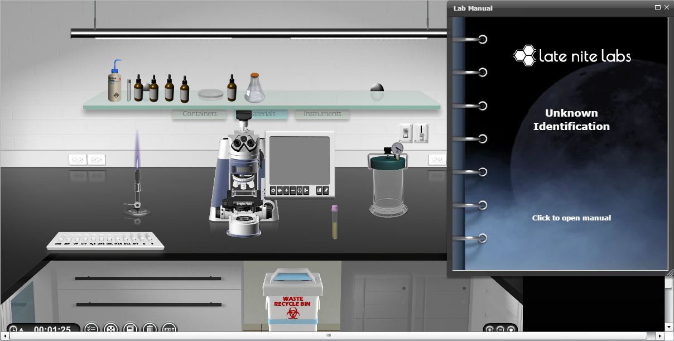

Figure 1: Image of the front page of Unknown Lab.

In this lab you will follow the schematic in the procedures to determine which tests to use to identify your unknown bacterial species.

First you will use a series of individual tests determine only one or two traits. Ultimately, you’ll experience how those traits create a complex picture of a complete organism when you use all your data to identify your sample’s species.

## Procedures:

During Module 7, we reviewed all the steps in identifying an unknown bacterial species obtained from the environment. Your task is to identify the unknown sample given to you using the biochemical tests we have performed over the past 12 weeks.

1. To complete the lab, please visit our LateNiteLabs course website as usual @ [Late Nite Labs](http://www.latenitelabs.com).
2. Review the information we covered in the live class meeting at the beginning of the week. If you did not have a chance to view it, please see the recorded session saved in module 7.
3. Complete the following lab according to the steps in the three lab tests listed below. Remember to take notes, photos, and videos using the tools in the lab application and save them to help you identify your unknown.
4. After completing the three tests, submit the answers to the questions in LateNiteLabs (the questions will be typed below for your reference) and post the identification of the bacteria in LateNiteLabs for grading. As always, please see me if you need help or guidance.

Follow the schematic below to determine which tests to use to identify your unknown bacterial species. Below the schematic is a review of the procedures for the experiments.

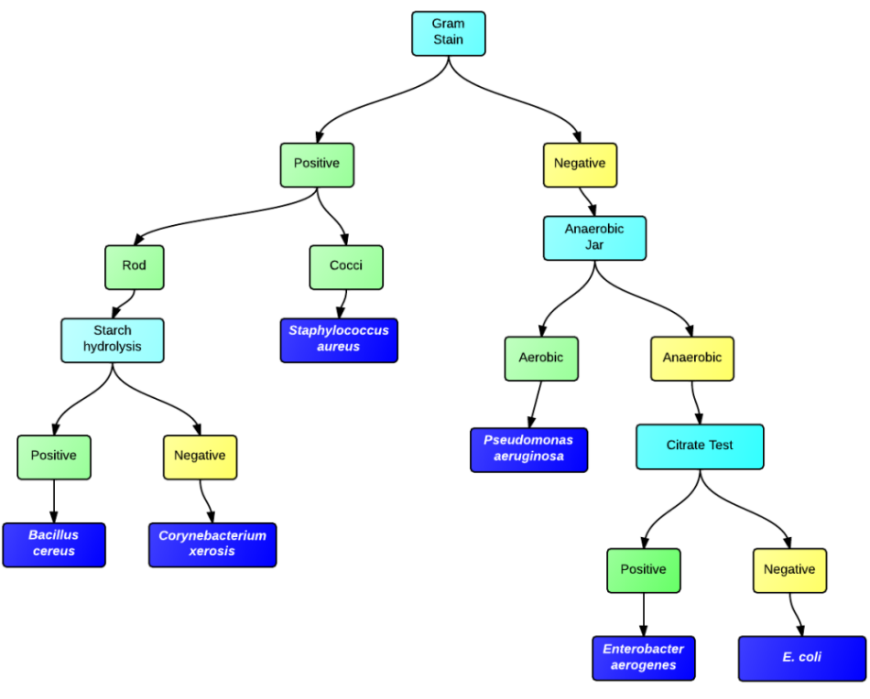

Figure 2: Schematic of Steps for Identifying the Environmental Unknown

## Test 1: Gram Staining

1. Place a staining pan from the Instruments shelf onto the workbench.
2. Place an empty slide from the Containers shelf onto the staining pan.
3. Place the Unknown Culture from the Materials shelf onto the workbench.
4. Place a Bunsen burner from the Instruments shelf onto the workbench. Turn on the Bunsen burner by clicking the knob at the bottom center three times to obtain a hot, concentrated dark blue flame.
5. Place the wire rod from the Instruments shelf onto the Bunsen burner to sterilize it.
6. Move the wire rod into the Unknown Culture tube.
7. Move the wire rod onto the middle of the empty slide to transfer bacteria onto the slide.   
   *Note: The slide is now labeled Unknown Culture.*Make sure your cursor lands on part of slide, outlined below, when applying any instrument or material to it.
8. Discard the wire rod into the recycling bin.
9. Drag the slide through the flame of the Bunsen burner two times, then return it the staining pan.
10. Review these staining and washing techniques, then follow the order of operations listed in the Staining Chart.

* *Stain:* Place the stain/decolorizer bottle from the Materials shelf onto the workbench.
  + Stain the slide by moving the top off the dropper bottle and onto the slide. Observe the color of the slide change.
* *Wash*: Place a water bottle from the Materials shelf onto the bacterial slide. Observe the water washing off excess stain from the slide.

|  |
| --- |
| **Staining Table** |
| Stain: Crystal Violet |
| **Wash** |
| Mordant: Potassium Iodine |
| **Wash** |
| Decolorize: 95% ethanol |
| **Wash** |
| Stain: Safarin |
| **Wash** |

*Table 1: Staining Chart*

1. Once finished discard all the stains in the recycling bin.
2. Place a microscope from the Instruments shelf onto the workbench.
3. Examine the slide under the microscope and annotate with the following:
   1. circle and label bacteria (Gram positive or Gram negative)
   2. **save and label the image to your portfolio**
4. Clear the workbench.

## Test 2: Rapid ID Tray: For Starch Hydrolysis or the Citrate Test

1. Place the rapid identification tray from the Instruments shelf onto the workbench.
2. Place the Unknown Culture from the Materials shelf onto the workbench.
3. Depending on your results, use a dropper to fill either the STA or CIT cell with 1 drop of the unknown culture. Discard the culture tube.
4. Place an incubator from the Instruments shelf onto the workbench. Move the rapid identification tray inside of it.
5. Run the incubator on these settings:
   * 24 hours
   * 35°C
   * When incubation is complete, move the rapid identification tray onto the workbench. If you’re performing the STA (Starch Hydrolysis) Test, continue onto step 6.
   * If you’re performing the CIT (Citrate) Test, your test does not require the addition of new reagents after incubation.  Now check your results based on the table below.
6. Place the iodine reagent onto the workbench.
7. Add iodine into the STA microtube of the rapid identification tray. Discard the bottle.
8. Check your results based on the table below.

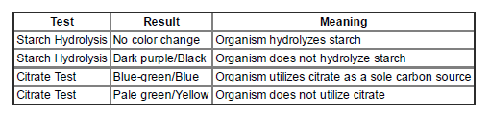

*Table 2: Starch/Citrate Result Table for Comparison*

## Test 3: Anaerobic Jar Test

1. Plate your Unknown Culture according to the chart below.
2. Using the method outlined in previous labs, sterilize your spreader with a beaker, isopropanol, and Bunsen burner.
3. For each plate, spread the bacteria with a sterile L-shaped spreader.
4. Place an Anaerobic jar on the workbench and move the anaerobic plate into it.
5. Place two incubators on the workbench. Place the anaerobic jar in one incubator and the stack of aerobic plates in the other.
6. Run the incubators on these settings:
   1. 24 hours
   2. 35 C
7. When incubation is complete, move the contents onto the workbench. Move the plate from the Anaerobic jar to the workbench. Discard the jar and the incubators.
8. Place the Projection Magnifier on the workbench.
9. Classify the contents of each plate by observing it under the Projection Magnifier. You will:
10. Drop the plate into the magnifier. Observe the plate for growth. Use the table below to begin classifying the bacteria and record the information in your Lab Notes.
11. Use the Annotation tools in the lower right corner of the viewing screen to label it.
12. **Take a snapshot by clicking the camera button and save in the images in your portfolio.**
13. Use the following table to help you interpret the results.

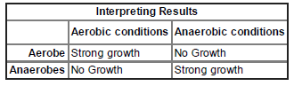

*Table 3: Anaerobic Jar Table Results for Comparison*

## Part 4: Answer the Questions and Identify your Unknown

1. In Late Nite Labs, please answer the following questions in order to receive evaluation of your unknown.
   1. What was the identity of your unknown bacterial species? How do you know?
   2. What was the overarching purpose of this experiment? Why were you asked to identify an unknown, not to identify a bacterial species?
   3. A student discovers that her unknown bacterial sample is a Gram positive rod that hydrolyzes starch. The bacterial sample is most likely… ______________________.
   4. A student discovers that his unknown bacterial sample is a Gram negative rod that is anaerobic and CIT positive. The bacterial sample is most likely ________________.
   5. Which of the following (there may be more than one correct answer) are feasible application of unknown bacterial species identification?
      1. Environmental microbiologists studying ape species to determine which would be the best model organisms to simulate human diseases
      2. Environmental microbiologists identifying species to monitor ecosystems' response to stress.
      3. Agricultural microbiologists identifying species to treat outbreaks among crops or livestock.
      4. Clinical microbiologists studying the microorganisms to determine which would best produce synthetic plastics
      5. Agricultural microbiologists studying the microorganisms that maintain soil fertility by transforming nutrients through degradation and nitrogen fixation

Please see the following Checklist to ensure you have completed all steps before submitting your assessment.

# Performance Task: Identification of Bacterial Unknown from the Environment

# Student Checklist

|  |  |
| --- | --- |
| **Activity / Step** | **Complete** |
| Complete Readings and Activities in Module 7 |  |
| Attend virtual meeting on Final Lab Activity in Blackboard Collaborate (or watch recording) |  |
| Read Student Instruction Sheet before starting the virtual lab. |  |
| Review bacterial characteristics of the following bacteria (any one of the following could be your biological unknown).   * + - *Escherichia coli*     - *Enterobacter aerogenes*     - *Klebsiella pneumoniae*     - *Shigella dysenteriae*     - *Salmonella typhimurium*     - *Proteus vulgaris*     - *Pseudomonas aeruginosa*     - *Alcaligens faecalis*     - *Staphylococcus aureus*     - *Lactococcus lactis*     - *Miccrococcus luteus*     - *Corynebacterium xerosis*     - *Bacillus cereus* |  |
| Complete test 1: Gram Stain (save images and notes in the lab for reference) |  |
| Complete test 2: Biochemical Tests (save images and notes in the lab for reference) |  |
| Complete test 3: Anaerobic jar (save images and notes in the lab for reference) |  |
| Schedule meeting with Professor Williams for feedback (only if needed… not required) |  |
| Identify Biological Unknown |  |
| Answer Questions in Late Nite Labs and hit submit. |  |

# Performance Task: Identification of Bacterial Unknown from the Environment

# Rubric

Name: _____________________________________ Date: _____________________

|  |  |  |  |
| --- | --- | --- | --- |
| **Assessment Rubric** | | | |
| **Criteria** | **0 points** | **5 points** | **10 points** |
| **Virtual Class Meeting** | Student did not view or attend the virtual class meeting. | Student did view or attended the virtual class meeting. |  |
| **Test 1 (Gram Stain)** | Student did not attempt the Gram Stain Technique or did not accurately perform the gram stain. | Student completed the Gram Stain Technique with limited understanding and inaccurately interpreted the results. | Student completed Gram Stain Technique with understanding and accurately interpreted the results. |
| **Test 2 (Biochemical Tests)** | Student did not attempt the Biochemical Tests or did not accurately perform the Biochemical Tests. | Student completed the Biochemical Tests with limited understanding and inaccurately interpreted the results. | Student completed the Biochemical Tests with understanding and accurately interpreted the results. |
| **Test 3 (Anaerobic Jar)** | Student did not attempt the Anaerobic Jar Test or did not accurately perform the Anaerobic Jar Test. | Student completed the Anaerobic Jar Test with limited understanding and inaccurately interpreted the results. | Student completed the Anaerobic Jar Test with understanding and accurately interpreted the results. |
| **Lab Questions** | Student did not complete discussion questions or did not explain answers fully. | Student completed the discussion questions with limited understanding of the results. | Students completed discussion questions with full understanding of the results. |
| **Identification of Biological Unknown** | Student incorrectly identified biological unknown or failed to make a conclusion. | Student correctly identified the biological unknown. |  |

**Total Points: __ /50**

**Comments:__________________________________________________________________________________________________________________________________________________________________________________________________________________________________________________________________________________________________________________________________________**